Integrated Math 2: How to get your E-Book
2021-2022, Mrs. Jones
- Go to ebooks.cpm.org and click “Self-enroll”

2) Enter the PIN: NMNP8
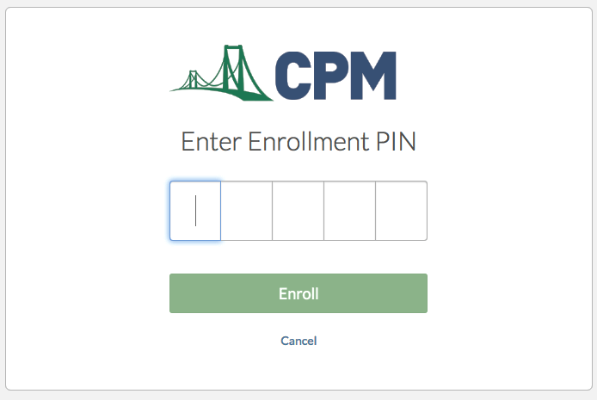

3) Click “Need an account?” or use your Sutter Union HS google account to log in (@sutterhigh.org).

4) IF you are creating a new account, fill in this information and click “Register”
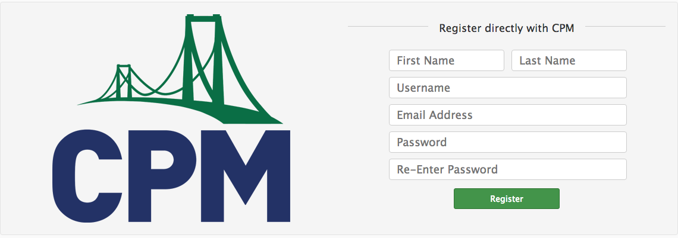

5) Accept the terms at the bottom of the next page:
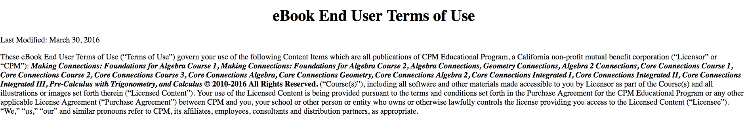

6) Access your book by clicking on the image (English version on the left, Spanish version on the right):
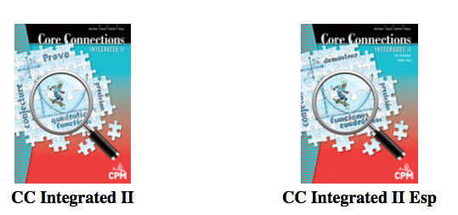

For future access, you can simply visit: https://ebooks.cpm.org
Enter your username and password

