Google Classroom - Join with a class code
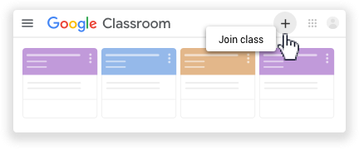
Your teacher can tell you the class code. After you get the code, follow these steps:

- Go to classroom.google.com.
- Make sure to sign in with the correct account. If you're already signed in and need to switch accounts, in the top-right corner, click your profile picture select or add your account. YOU MUST USE YOUR @sutterhigh.org EMAIL.
- At the top, click Join class.
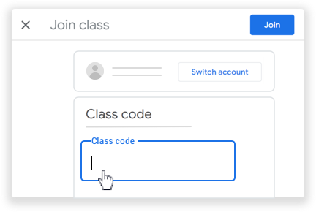

- Enter the class code from your teacher and click Join.

Note: Class codes are 6-7 characters, and use letters
and numbers. Codes can’t have spaces or special
symbols.

YOUR EMAIL: School ID @ sutterhigh.org. For example, if your ID is 12345, your email is 12345@sutterhigh.org.
The email password is SUHSD12345 (replace 12345 by your own ID).

Class Code for Integrated 2: x5ffpkc
Class Code for Integrated 1: ev3e66p

